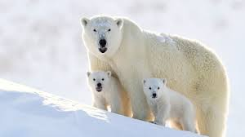Object Oriented Programming

Class: Bear

Properties:

1. Have claws.
2. Carnivore
3. Mammals
4. Weight

Behaviour:

1.Eat()

2.Play()

3.Hunt()



Behaviour:

1.heating()

2.lights()

3.electricity()

Properties:

1. Voltage

2. Colour Temperature

3. Intensity

4. Mean Life

Class: Lamp

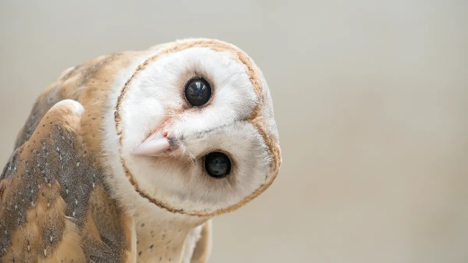

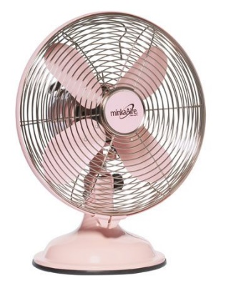

Behaviour:

1. Electricity()
2. Wind()
3. Cold()

Behaviour:

1. Dive()
2. Jump()
3. Fly()

Properties:

1. Brand
2. Size
3. Windpower

Class: Fan

Properties:

1. Wings
2. Size
3. Breed

Class: Bird



Behaviour:

1. Ink()
2. Writing()
3. Doodling()

Properties:

1. Brand
2. Type
3. Size

Class: Pen